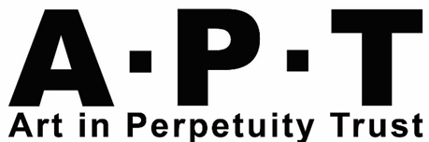
Clyde Hopkins Mentoring Award
Application Form
Closing date: 29th April 2024

Name:
Address:
Telephone:
Email:
Website / social media:
- Do you live or work in London Borough of Lewisham? Please delete as appropriate:
Yes / no Live / Work

- Please tell us about your practice and the underlying motivation for your work (300 words max)

- What do you hope to gain from taking part in the Clyde Hopkins Mentoring Award? (250 words max)

- Do you currently have a studio? If so, who is your studio provider and where are you based?

- Do you have any access requirements that we might be able to support you with?

- Where did you hear about this mentoring award?

