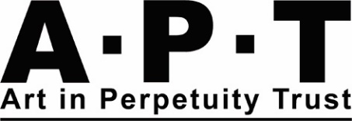
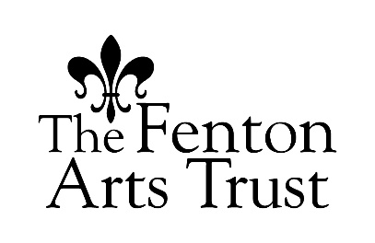
A.P.T & Fenton Arts Trust Mentoring Award
Application Pack
Closing date: 5pm Wednesday 10 May 2023
Interviews: 1 June 2023
Introduction:
Now in its third year, with further funding from The Fenton Arts Trust, the A.P.T & Fenton Arts Trust Mentoring Award provides mentoring and a free studio space for one year, for two emerging artists or recent graduates, whose practice is multi-disciplinary (innovative fine art, installation, time-based media, lens-based media, performance, socially engaged practice). The awardees will receive free studio space, for a year, and advice and guidance on their fine art practice from a mentor, to help them release their full potential. This mentoring will be provided by A.P.T artist members: Bernice Donzselmann and Chris Marshall.
Starting in July 2023, this unique programme is designed to provide space and support during the period between education and professional life, with a collaborative one-to-one mentoring relationship. The Mentoring Award will benefit the mentees by helping them develop their practice, broadening their experience within a working studio-community/gallery-complex.
Background:
Established in 1995, The Art in Perpetuity Trust (A.P.T) is a registered charity whose mission is to actively encourage and support creative thought and artistic vision. At its freehold premises on the banks of Deptford Creek, A.P.T provides 42 secure studios for visual artists, a contemporary art gallery, and a working sculpture yard. A.P.T forges links and collaborations with the local community and other professional bodies locally, nationally, and internationally. It offers charitable support, both financial and in-kind, to all its projects, including the A.P.T Gallery exhibition and education programmes.
The Award:
The Mentoring Award is for two fine art graduates, who will be mentored by two A.P.T artists.
Criteria:
Artists who completed a first or second degree in Visual Arts no more than three years ago, or who completed a course at an equivalent alternative art school no more than three years ago.
The Mentee will receive:
- 1 year fully paid studio
- advice and support about their current practice
- a joint end of year event/exhibition, with support from their mentor
- opportunities to meet relevant members in the community of APT – artists, trustees and staff
- advice on their participation in Open Studios at A.P.T
- opportunities to take part in sub-committee meetings and the Annual General Meeting, to gain understanding and experience of how an art charity like APT operates
- induction to include Health & Safety tour, Data Protection Guidance and General APT information
- opportunities to be involved in other APT led projects throughout the year
The Mentee will be required to pay for their electricity usage. There will also be a security deposit of £115 to pay, which covers studio repairs, which will be refunded at the end of the residency.

Application Guidance Notes
Application details
- Please return the application form in PDF format to: info@aptstudios.org by 5pm 10 May 2023
- In the subject line of the email, type your full name followed by Mentoring Award.
- Please number, title and initial your images, as these will be assessed anonymously by the panel in the first round.
- Applications submitted after 5pm on the deadline will not be considered.
- We welcome and encourage applications from artists of all backgrounds. We particularly welcome applications from Black, Asian and Minority Ethnic backgrounds, as these groups are currently under-represented in the cultural sector.
We would be grateful if you would fill in and return the separate Equality and Diversity Monitoring Form with your application, which is downloadable from our website. When the application is received, the Monitoring form is removed and does not form part of your application. The information from this form helps us to monitor equality and diversity across APT.
Please type or write clearly in dark ink.

Access
Art in Perpetuity Trust (A.P.T) strives to be an equal opportunities employer and studio provider and welcomes applications from all sections of the community. A.P.T is partly wheelchair accessible due to the older sections of the building. One of the studios sits within a renovated complex, The Welding Shed and is fully wheelchair accessible, whilst the other studio is situated on the first floor and is partly accessible for wheelchair users.
Please contact the office at: info@aptstudios.org if you are unable to complete this form electronically or would like further information about access.
The Recruitment Process
We will aim to respond to applications by 26 May 2023. Due to the volume of applications, we will not be able to give feedback on unsuccessful written applications. This does not mean we don’t value the time and effort you’ve put into applying, but just that we do not have the resources to respond to each one individually.
Shortlisted Applicants will be invited to an interview at A.P.T. Interview will take place on 1 June 2023.
The interview:
N.B Let us know if this interview format provides any logistical issues and we will find another method/support
- The interview will be with the two project Mentors and A.P.T Artists; Bernice Donzselmann and Chris Marshall, Sarah Walsh, Administrative Director and David Oates, Chair of the A.P.T Vetting Subcommittee. The interview will last approximately one hour.
- The interview will be an opportunity for us to ask some questions about you practice, experience and expectations. We are interested in finding out what you might gain from this experience. It is also an opportunity for you to ask us any questions.
- We will provide feedback on all interviewed applicants and aim to get back to interviewees within two weeks

Application Form
Images
Alongside your application please submit by email, 10 images of your work. Or, if the work is time-based, then send links to works on Vimeo, YouTube or an equivalent platform, with passwords (if required). You will need to prioritise excerpts amounting to no more than 10 minutes viewing time in total. If you have additional non-time-based work, you can also include an additional 5 images. It is desirable that at least 5 of the images/clips relate to work made in the last three years. Please provide the following information
Format – Images should be sent as jpegs: 72dpi
Quantity - 10 images
Labelling –Please number, title and initial your images and/or links to work.
- Please tell us about the underlying motivation for your work (150 words max)

- Please tell us about the materials, processes and methods you use in developing and making your work (150 words max)

- What do you hope to gain from taking part in the A.P.T & Fenton Arts Trust Mentoring Award? (250 word max)

- Do you currently have a studio? If so, who is your studio provider and where are you based?

- Do you have any access requirements that we should know about?

- Where did you hear about this mentoring award?

- CV – Please list your artistic and professional activity for the past five years (no more than one side of A4)

